# Quick Use Menus

These menus will be shown on the Axis screen similar to the part highlighted in red below.

## Quick Use Menu 1

This is the 1st menu: It is designed for basic operation of the spindles (Sp1 is the Rosette Phaser/Multiplier).

Run Spindles

CW

**Sp0**

100%

Yes

CCW

**Sp1**

125%

Yes

Run

**0**

**100**

**Dir**

**Speed**

**Use?**

Use this spindle?

Button to start/stop the operation

Speed percentages: Used to set the relative speeds

Rotational Direction: CW or CCW

Slider to dynamically change the speed

## Quick Use Menu 2

This is the 2nd menu: It is designed for indexing the rotational axes.

Notes:

1. If more than one axis is set to Yes to use, they will be indexed together, each for the designated distance.
2. We need to design the slider so that it can be moved to adjust the speed when the system is running.
3. Each time the system is indexed, the counter is incremented.

**3**

**Indexing moves**

Index (Rotary)

Run

**0**

**100**

**Dir**

**Distance**

**Use?**

CW

**Sp0**

15.0

Yes

deg

CW

**Sp1**

0.0

No

deg

CCW

**B**

7.0

No

div

Rotational Direction: CW or CCW

Distance to move

Degrees or divisions of a circle

Count of the number of indexing movements

Use this axis?

## Quick Use Menu 3

This is the 3rd menu: It is designed for indexing the linear axes. Rather than using +/- for the direction, it may be more user friendly to denote the direction using names for the directions (in/out, up/down, and left/right).

As with the rotational axes, more than one linear axis can be selected for simultaneous movement.

Index (Linear)

Run

**0**

**100**

**Dir**

**Distance**

**Use?**

In

**X**

10.001

Yes

**in**

Up

**Y**

0.000

No

**in**

Left

**Z**

0.000

No

**in**

In

**U**

0.000

No

**in**

Up

**V**

0.000

No

**in**

## Quick Use Menu 4

**3**

**Indexing moves**

This is the 4th menu: It is designed for basic synchronized movement (e.g., threading). For anything more complicated, the user would need to use gCode.

Basic Sync Movement

**Dir**

**Distance**

**Use?**

CW

**Sp0**

270.0

Yes

CW

**Sp1**

180.0

Yes

In

**X**

0.000

No

Left

**Z**

10.030

Yes

Run

**0**

**100**

# Status Panel

This panel will be shown as a tab on the Axis screen similar to the part highlighted in red below.

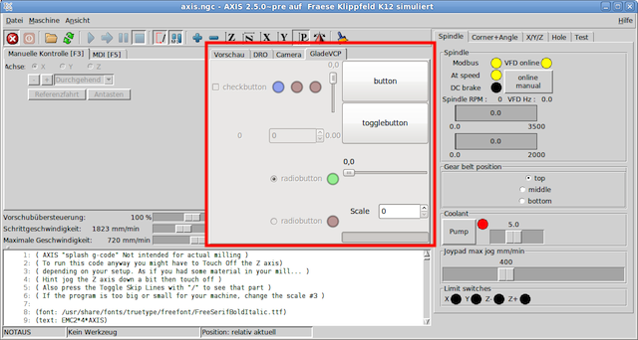

Rotary Axis

0.00

**B**

DPS

Linear Axes

0.000

**X**

IPS

0.000

**Y**

IPS

0.000

**Z**

IPS

0.000

**U**

IPS

0.000

**V**

IPS

Spindles

0.00

**Sp0**

RPM

0.00

**Sp1**

RPM

Enable status: red or green.

Current speed

Speed unit of measure  
(rev/min, inches/sec, or degrees/sec)